
The ARRIVE Guidelines Checklist

Preclinical Elucidation of Recombinant Humanized Anti-PD-1 Monoclonal Antibody (TA1718-B) Pharmacokinetics in Cynomolgus Monkeys, Rats and Colon Cancer Humanized Mice
Running title: Pharmacokinetics of new anti-PD-1mAb
Li-li Zhao^{1, 3†}, Yun-gang Lv^{2†}, Lan-fang Li^{1, 4}, Zeng-tian Liu^{1, 3}, Dong Ma^{1, 3}, Gui-min Zhang^{1, 3, 4},Zhong Liu^{1, 3, 4},Yu-shan Ren^{1, 3*}, Jie Li^{1, 4*}
¹ National Engineering Laboratory of High Level Expression in Mammalian Cells, Lunan Pharmaceutical Group Co. Ltd., Linyi, Shandong, China.
² Department of Radiology, Shenzhen University General Hospital, Shenzhen University Clinical Medical Academy, Shenzhen, China.
³ National Engineering and Technology Research Center of Chirality Pharmaceutical, Lunan Pharmaceutical Group Co. Ltd., Linyi, Shandong, China.
⁴ Pharmacological Center, Shandong New Time Pharmaceutical Co. Ltd., Feixian county, Linyi, Shandong, China.

 |  | ITEM | RECOMMENDATION | Section/  Paragraph
 |  |  |  | Title
 |  |  |  | Abstract, Paragraph 1
 | INTRODUCTION
 |  |  |  | Introduction, Paragraph 2-4
 |  |  |  | Introduction, Paragraph 4
 | METHODS
 |  |  |  | Methods, Paragraph 6
 | 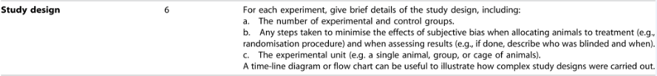 |  |  | Methods, Paragraph 7-9, 11, 12
 | 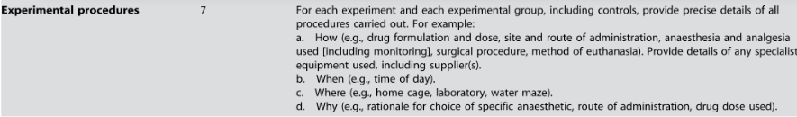 |  |  | Methods, Paragraph 7-9, 11, 12
 |  |  |  | Methods, Paragraph 7-9, 11, 12
 |  |  |  | Methods, Paragraph 7-9, 11, 12
 |  |  |  | Methods, Paragraph 7-9, 11, 12
a. Methods, Paragraph 7
b. N/A
 |  |  |  | N/A
a. Paragraph 19
b.c. N/A
 | RESULTS
 |  |  |  | N/A
 |  |  |  | N/A
 |  |  |  | Results, Paragraph 20-27
 |  |  |  | N/A
 | DISCUSSION
 | CUSSION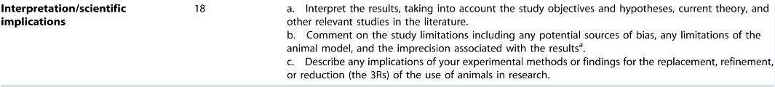 |  |  | Discussion, Paragraph 28-33
 |  |  |  | N/A
 |  |  |  | Declarations, Paragraph 42

The ARRIVE guidelines. Originally published in PLoS Biology, June 2010
 |  | Materials and Methods, Paragraph 6
 |  | Materials and Methods, Paragraph 6;  Results, Paragraph 12-14
 |  | Materials and Methods, Paragraph 7
 |  | Results, Paragraph 12-16
 |  | Materials and Methods, Paragraph 10
 | RESULTS
 |  | All mice in each group were health prior to treatment.
 |  | Results, Paragraph 12-14
 |  | Results, Paragraph 12-16
 |  | No adverse events were observed in any experimental group
 | DISCUSSION
 |  | Discussion,  Paragraph 17-20
Discussion,
Paragraph 21
 |  | Information of Funding only be showed on online system. Namely “The work was funded by the National Major Program Project Grant Against Infectious Diseases (Grant No.2013ZX10001002-002-002).”



